**Name : Baljeet UID : 22BCS11134 Section : 605-B Assignment -4**

**Ques 1. Longest Nice Subsrtring.**

**Code:**

class Solution {

public:

    string longestNiceSubstring(string s) {

        int n = s.length();

        if (n < 2) return "";

        for (int i = 0; i < n; ++i) {

            char ch = s[i];

            if (s.find(tolower(ch)) == string::npos || s.find(toupper(ch)) == string::npos) {

                string left = longestNiceSubstring(s.substr(0, i));

                string right = longestNiceSubstring(s.substr(i + 1));

                return left.length() >= right.length() ? left : right;

            }

        }

        return s;

    }

};

**Output:**

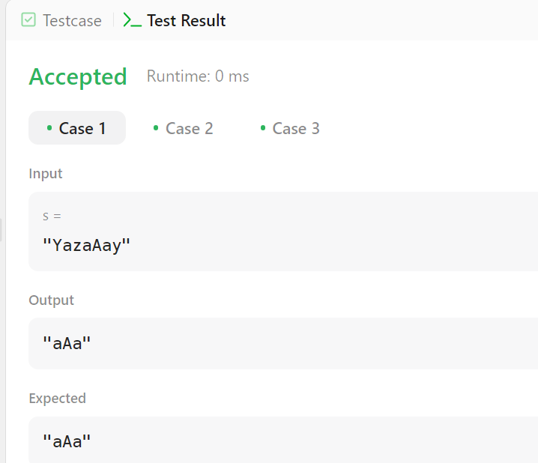

**Ques 2. Reverse Bits.**

**Code:**

class Solution {

public:

    uint32_t reverseBits(uint32_t n) {

        uint32_t result = 0;

        for (int i = 0; i < 32; i++) {

            result = (result << 1) | (n & 1);

            n >>= 1;

        }

        return result;

    }

};

**Output:**

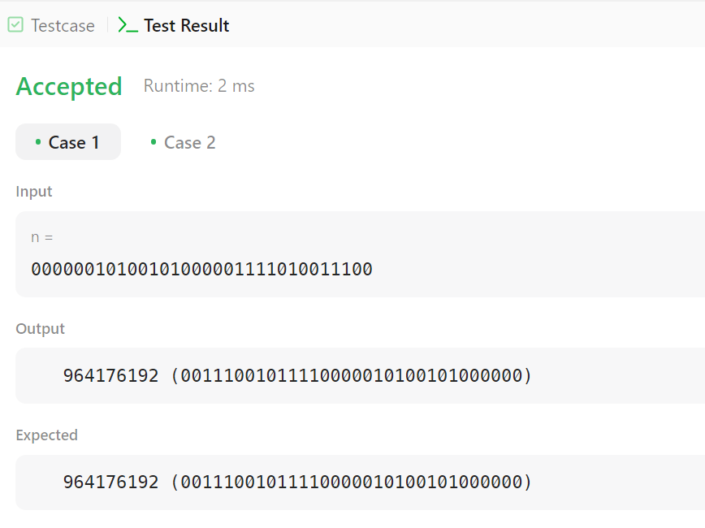

**Ques 3. Number of 1 Bits.**

**Code:**

class Solution {

public:

int hammingWeight(int n) {

int count = 0;

while (n) {

count += (n & 1); // Add 1 if the last bit is set

n >>= 1; // Right shift n to check the next bit

}

return count;

}

};

**Output:**

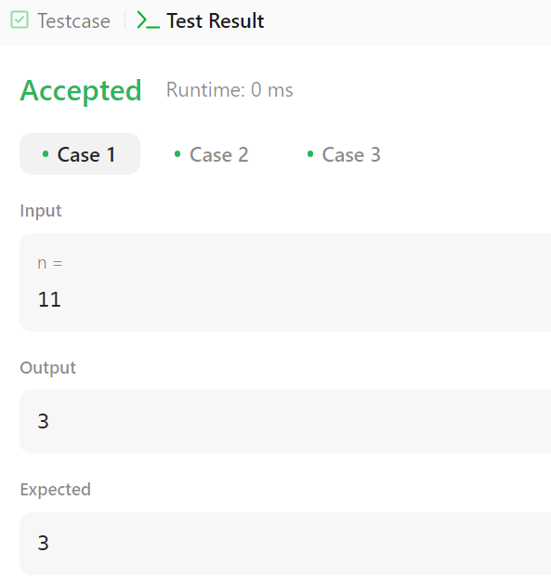

**Ques 4. Maximum Subarray.**

**Code:**

class Solution {

public:

int maxSubArray(vector<int>& nums) {

int maxSum = nums[0], currentSum = nums[0];

for (int i = 1; i < nums.size(); i++) {

currentSum = max(nums[i], currentSum + nums[i]);

maxSum = max(maxSum, currentSum);

}

return maxSum;

}

};

**Output:**

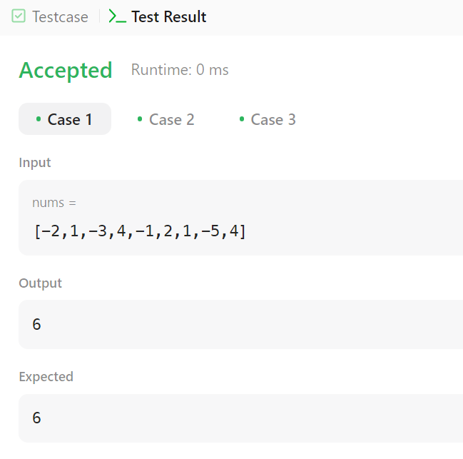

**Ques 5. Search a 2-D matrix II.**

**Code:**

class Solution {

public:

bool searchMatrix(vector<vector<int>>& matrix, int target) {

int m = matrix.size(), n = matrix[0].size();

int row = 0, col = n - 1; // Start from the top-right corner

while (row < m && col >= 0) {

if (matrix[row][col] == target) return true; // Found the target

else if (matrix[row][col] > target) col--; // Move left

else row++; // Move down

}

return false;

}

};

**Output:**

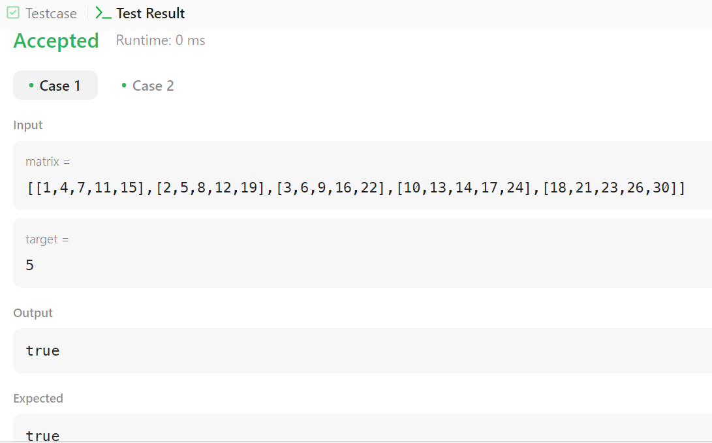

**Ques 6. Super Pow.**

**Code:**

class Solution {

public:

    const int MOD = 1337;

    int modPow(int a, int b) {

        int result = 1;

        a %= MOD;

        while (b > 0) { a = (a * a) % MOD;

            b /= 2;}

        return result;

    }

    int superPow(int a, vector<int>& b) {

        a %= MOD;

        int result = 1;

        for (int digit : b) {

            result = (modPow(result, 10) * modPow(a, digit)) % MOD; }

        return result;

    }

};

**Output:**

